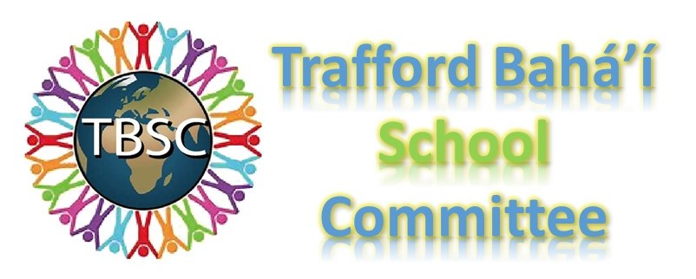

Framework for Bahá’í Presentation
The Bahá’ís of Trafford created this presentation to be in alignment with the Trafford Agreed Syllabus for Religious Education. The aim of this document is to introduce the teachers to the presentation and give a framework for understanding the content.
Overview of the Bahá’í Faith
The Bahá’í Faith is the youngest independent world religion and one of the fastest growing in the world. It is a global community where it is established in more than 100,000 localities in virtually every country and territory around the world.
Bahá’u’lláh, the Prophet Founder of the Bahá’í Faith, was born in Persia in 1817. Among His core teachings are: unity of races and nations, the oneness of God and religions, the equality of men and women and the harmony of science and religion. Bahá’u’lláh explained there is one God and that all religions come from the same God. God has been sending an eternal series of Divine Teachers to take humanity forward. Bahá’u’lláh declared that He was the latest in this series of Divine Teachers. Bahá’ís often compare this to a child going into a new class each year at school, learning more from each new teacher.
For more information about the Bahá’í Faith, we invite you to visit www.bahai.org.
About the Materials
The materials that we have prepared for schools include PowerPoint presentations that will address each of the topics that are in the Trafford Agreed Syllabus for Religious Education, as well as PDFs of lesson plans, activity worksheets, and class activities that can be explored with the students alongside the presentations. Please check www.traffordbahais.org.uk for materials for the Foundation Stage, Key Stage 1, Key Stage 2 and Key Stage 3.
With regard to the PowerPoint presentations, please keep the following in mind:
- We recommend that the teachers review the lesson plan ahead of time as it will give them context for understanding the material.
- Where possible we have included writings from the Bahá’í Faith as this is the main source of inspiration for Bahá’ís.
- Bahá’u’lláh did not teach using parables. The acts and deeds of Bahá’u’lláh’s life are considered to be examples of how to live a good life.
- Bahá’u’lláh taught using metaphors to understand ideas and concepts (e.g. “Ye are the flowers of one garden, the leaves of one branch, the fruits of one tree.”) Wherever possible we have tried to include and reference writings that we feel are age appropriate for the students to understand.
- The portrayal of Bahá’u’lláh in works of art such as drawings, paintings, drama, photography, film etc. is not allowed out of respect for His station.
- In the presentations we share Bahá’í prayers/writings and songs as examples; however, pupils and teachers are not obliged to join in.
As we are always striving to improve our materials, we welcome feedback both negative and positive from teachers, for feedback form https://forms.gle/ufrRvFVFCKH3XFcs8 . We would like to openly collaborate with you so that the material is easy to use and easy to understand and engaging for students. Please feel free to contact us at: school@traffordbahais.org.uk.
Further Resources
More resources can be downloaded and freely copied at http://re.bahai.org.uk Furthermore, members of our Bahá’í Community are happy to visit schools to help lead lessons if teachers are interested. This is free of charge. Please contact us at www.traffordbahais.org.uk to arrange this.
The following websites provide further information on the Bahá’í faith which may be of use to teachers of R.E.:
www.bahai.org
The official website of the Bahá’í International Community.
www.bahai.org.uk
The official website of the Bahá’ís of the United Kingdom.

